**Проект «Describing the appearance»**



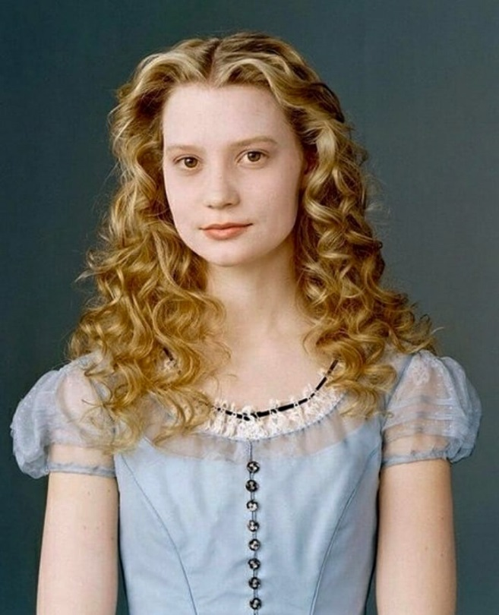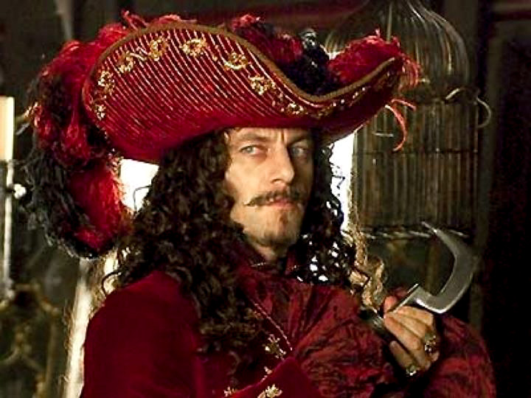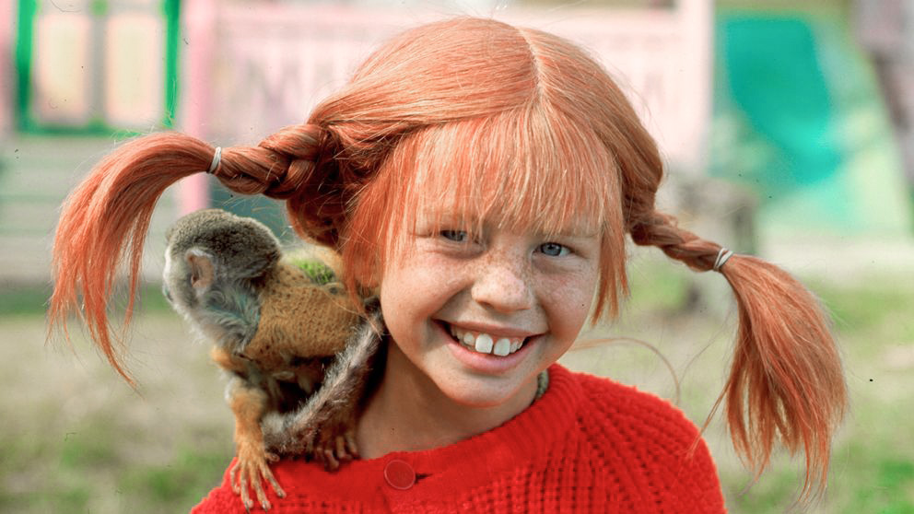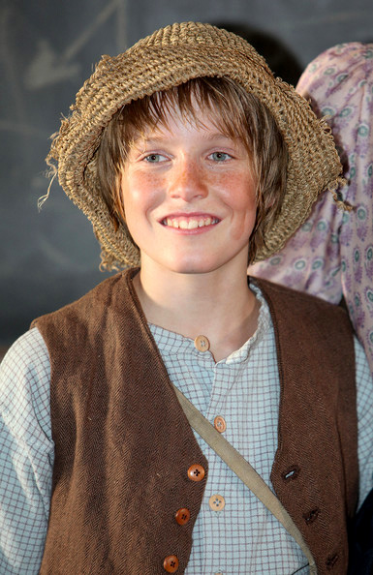

Picture 1. Alice in Wonderland

Picture 4. Captain Hook

Picture 3. Pippi Longstocking

Picture 2. Tom Sawyer